**ASSIGNMENT 3**  
  
**case 21**: From the following table, write a SQL query to find those employees whose experience is more than 27 years.

Return complete information about the employees

select * from globetechtb231

where months_between(sysdate,hire_date)>27*12;

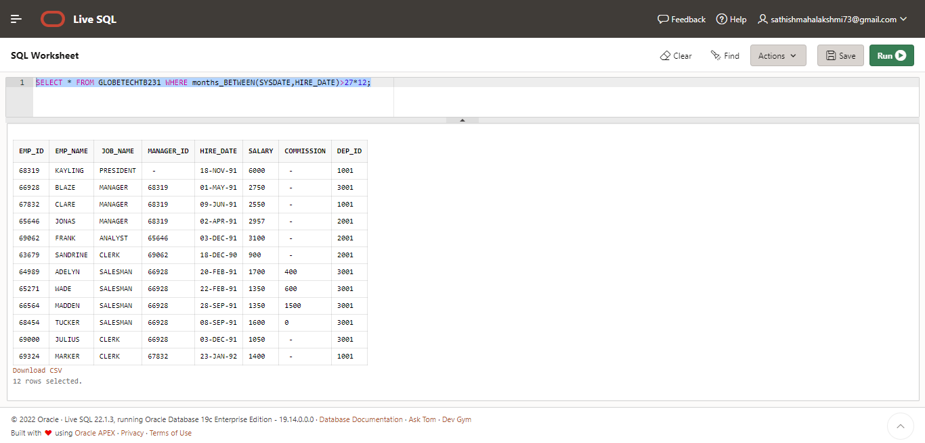

**case 22**: From the following table, write a SQL query to find those employees whose salaries are less than 3500.  
Return complete information about the employees.

SELECT *FROM globetechtb231

WHERE salary <3500;

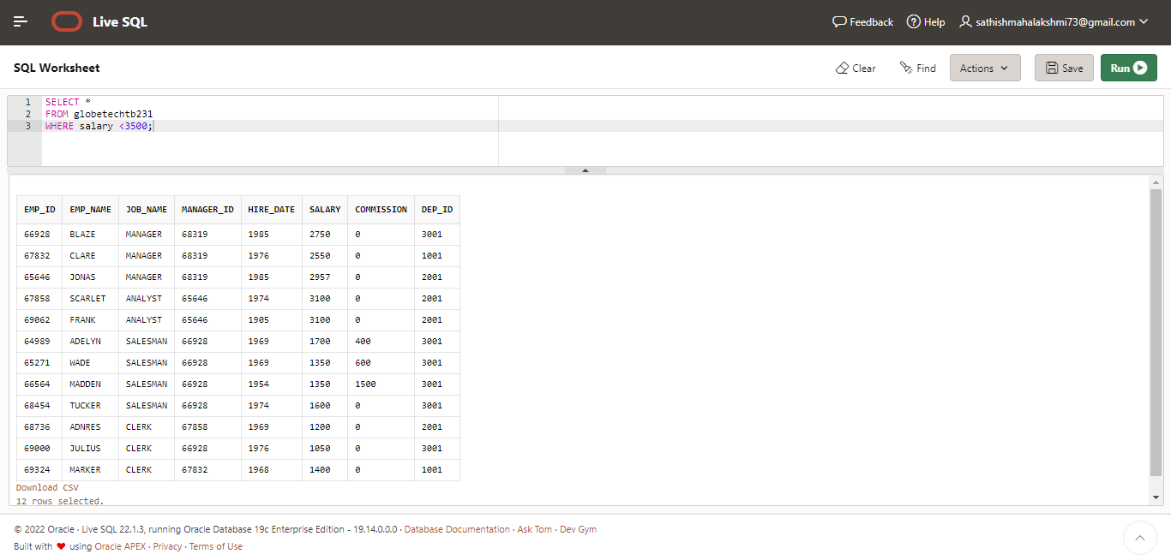  
**case 23:** From the following table, write a SQL query to find the employee whose designation is ‘ANALYST’.Return employee name, job name and salary

select emp_name,

job_name,

salary

from globetechtb231

where job_name = 'analyst';

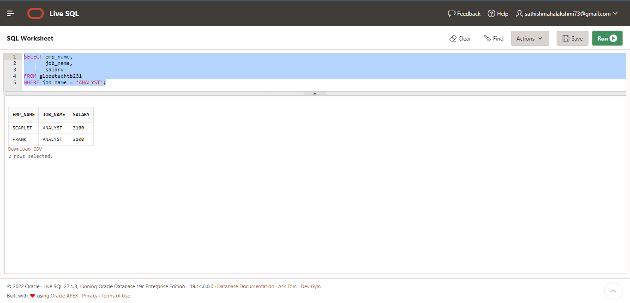

**case 24 :** From the following table, write a SQL query to find those employees who have joined in the year 1991.  
Return complete information about the employees

select *

from globetechtb231

where to_char(hire_date,'yyyy') = '1991';

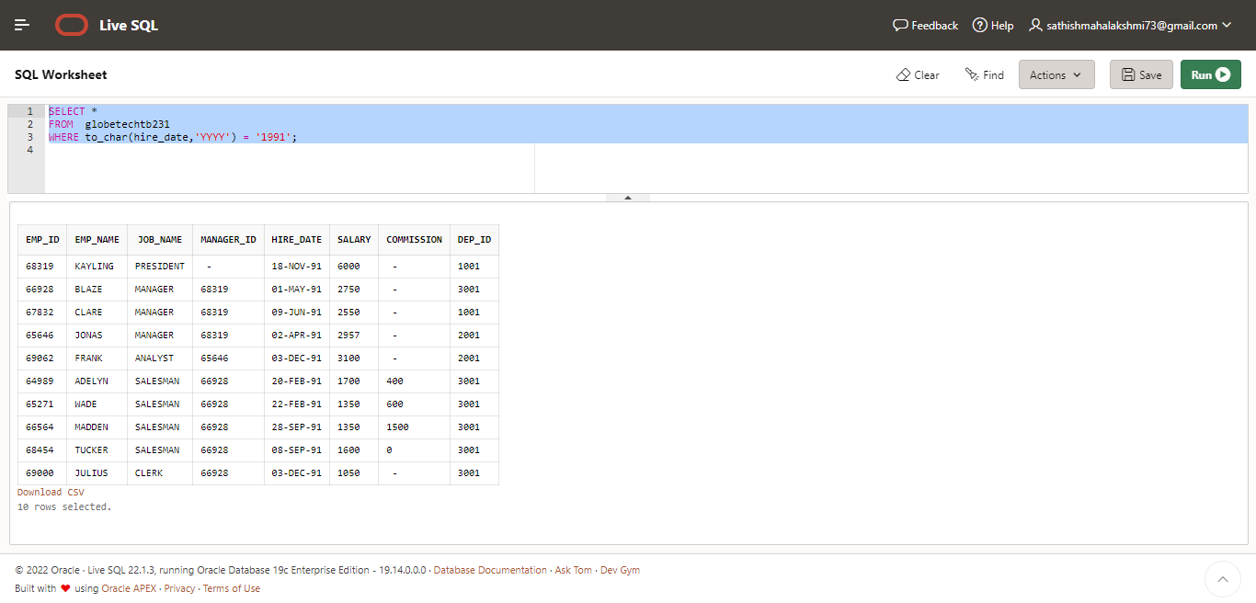  
  
**case 25:** From the following table, write a SQL query to find those employees who joined before 1st April 1991.  
Return employee ID, employee name, hire date and salary

select e.emp_id,e.emp_name,e.hire_date,e.salary

from globetechtb231 e

where hire_date<’01-apr-1991’;

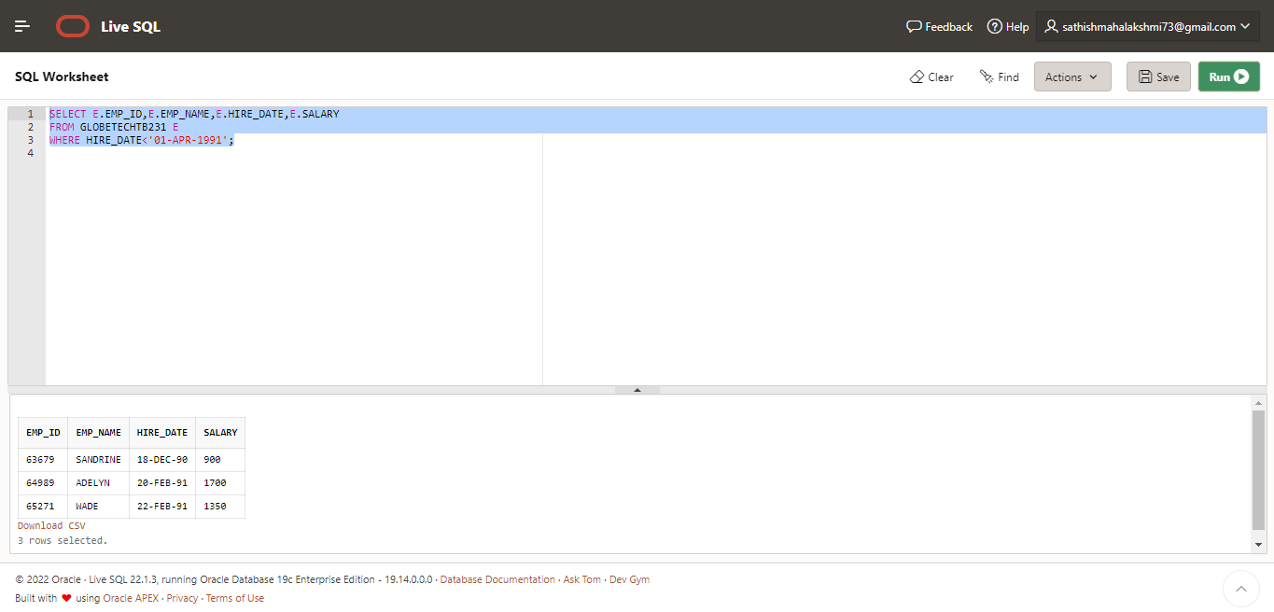  
**case 26:** From the following table, write a SQL query to find those employees who are not working under a manager.  
Return employee name, job name.

select e.emp_name,

e.job_name

from globetechtb231 e

where manager_id is null;

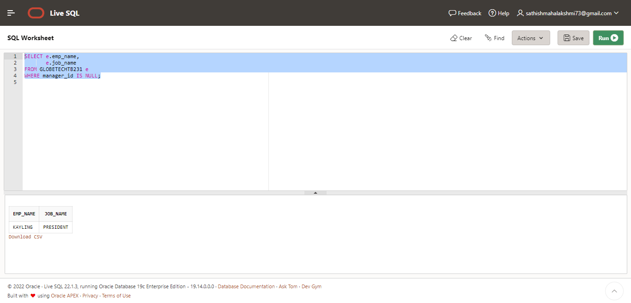

**case 27:** From the following table, write a SQL query to find those employees who joined on 1st May 91.  
Return complete information about the employees.

select *

from globetechtb231

where hire_date = '01-may-1991';

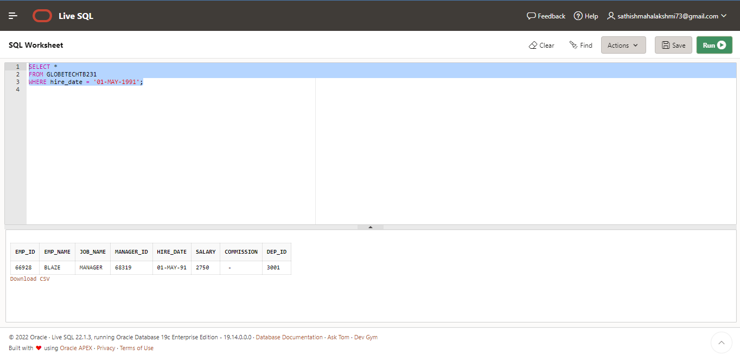  
**case 28** :From the following table, write a SQL query to find those employees working under the manger whose ID is 68319.  
Return employee ID, employee name, salary, and age.

Select emp_id,emp_name,salary,trunc(months_between(sysdate,hire_date)/12) as “age”

From globetechtb231 where manager_id=68319; Select emp_id,emp_name,salary,trunc(months_between(sysdate,hire_date)/12) as "age" from globetechtb231 where manager_id=68319;

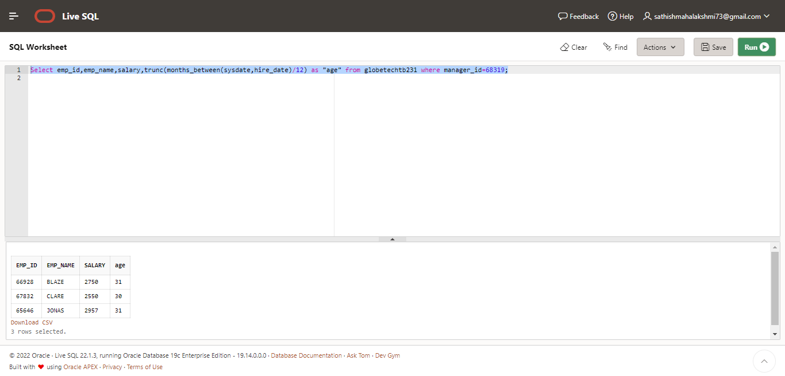  
**case 29 :**From the following table, write a SQL query to find those employees who earn more than 100 as daily salary.  
Return employee ID, employee name, salary, and age.

select emp_id,emp_name,salary, round(months_between(sysdate,hire_date)/12) as "Experience" from globetechtb231 where salary/30>100;

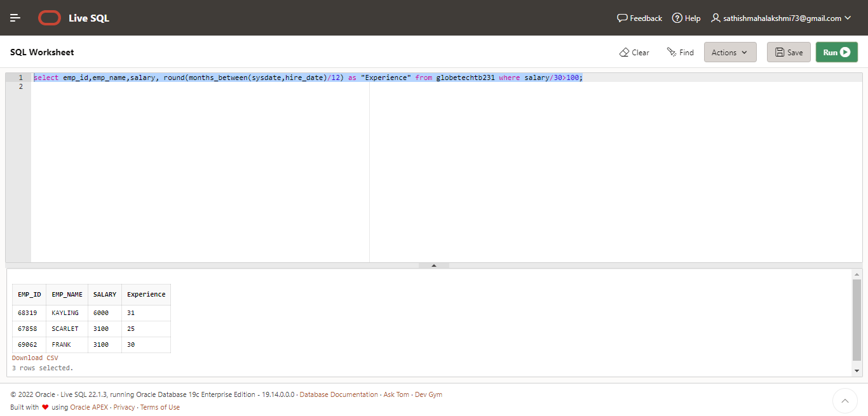

**case 30** :From the following table, write a SQL query to find those employees who retired after 31-Dec-99,  
completion of 8 years of service period. Return employee name.

select emp_name from globetechtb231

where months_between(to_date(‘1999-12-31’,’yyyy-mm-dd’),hire_date)/12>8;

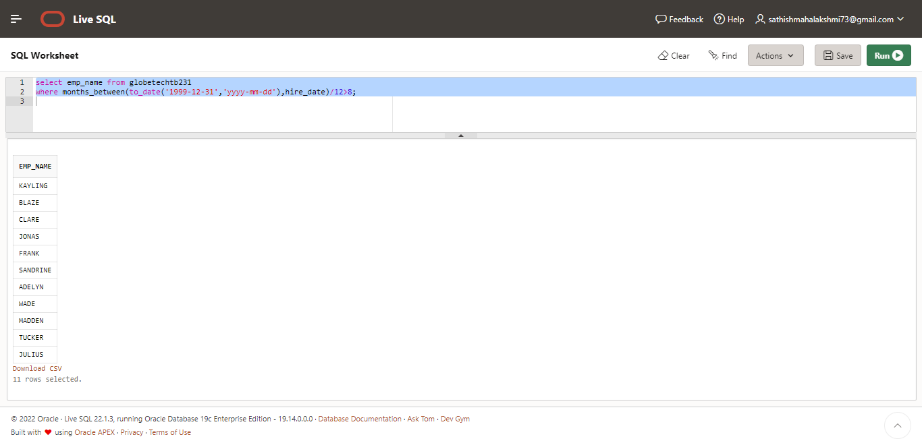

**case 31 :**From the following table, write a SQL query to find those employees whose salary is an odd value.  
Return complete information about the employees.

select *

from globetechtb231

where mod(salary,2) = 1;

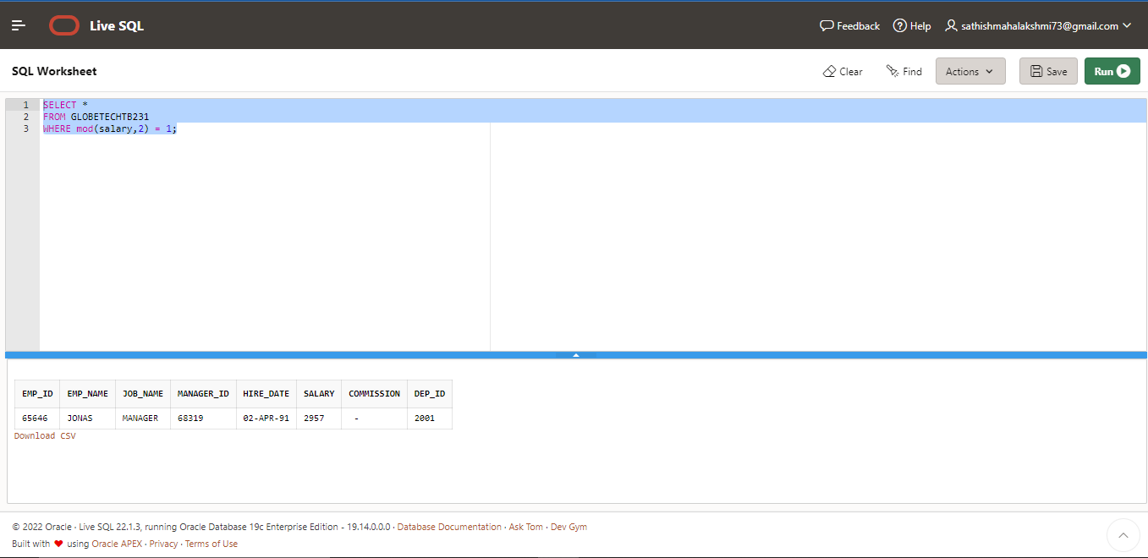  
**case 32 :**From the following table, write a SQL query to find those employees whose salary contains only three digits.  
Return complete information about the employees

select *

from globetechtb231

where length(trim(to_char(salary,'9999'))) = 3;

